React App- ToDo List

Full credit - <https://www.youtube.com/watch?v=EeLPE_3xals>

https://github.com/corymaklin

PS C:\temp\connectme> aws dynamodb create-table --table ToDoLst --attribute-definitions AttributeName=Id,AttributeType=S AttributeName=Task,AttributeType=S --key-schema AttributeName=Id,KeyType=HASH AttributeName=Task,KeyType=RANGE --provisioned-throughput ReadCapacityUnits=5,WriteCapacityUnits=5

{

"TableDescription": {

"AttributeDefinitions": [

{

"AttributeName": "Id",

"AttributeType": "S"

},

{

"AttributeName": "Task",

"AttributeType": "S"

}

],

"TableName": "ToDoLst",

"KeySchema": [

{

"AttributeName": "Id",

"KeyType": "HASH"

},

{

"AttributeName": "Task",

"KeyType": "RANGE"

}

],

"TableStatus": "CREATING",

"CreationDateTime": 1603911809.325,

"ProvisionedThroughput": {

"NumberOfDecreasesToday": 0,

"ReadCapacityUnits": 5,

"WriteCapacityUnits": 5

},

"TableSizeBytes": 0,

"ItemCount": 0,

"TableArn": "arn:aws:dynamodb:us-east-1:328837818148:table/ToDoLst",

"TableId": "5f537156-4dc9-4f16-80b9-c8b06c519688"

}

Create trusted_entity.json

|  |
| --- |
| { |
|  | "Version": "2012-10-17", |
|  | "Statement": [ |
|  | { |
|  | "Effect": "Allow", |
|  | "Principal": { |
|  | "Service": [ |
|  | "lambda.amazonaws.com" |
|  | ] |
|  | }, |
|  | "Action": "sts:AssumeRole" |
|  | } |
|  | ] |
|  | } |

aws iam create-role --role-name lambda-role --assume-role-policy-document file://trusted_entity.json

{

"Role": {

"Path": "/",

"RoleName": "lambda-role",

"RoleId": "AROAUZECC44SMIEQQASZ4",

"Arn": "arn:aws:iam::328837818148:role/lambda-role",

"CreateDate": "2020-10-28T19:11:12Z",

"AssumeRolePolicyDocument": {

"Version": "2012-10-17",

"Statement": [

{

"Effect": "Allow",

"Principal": {

"Service": [

"lambda.amazonaws.com"

]

},

"Action": "sts:AssumeRole"

}

]

}

}

}

Lambda policy for DynamoDB input

|  |
| --- |
| { |
|  | "Version": "2012-10-17", |
|  | "Statement": [ |
|  | { |
|  | "Effect": "Allow", |
|  | "Action": [ |
|  | "dynamodb:PutItem", |
|  | "dynamodb:Scan" |
|  | ], |
|  | "Resource": "arn:aws:dynamodb:us-east-1:084696551378:table/ToDoList" |
|  | } |
|  | ] |
|  | } |

aws iam put-role-policy --role-name lambda-role --policy-name dynamodb-access --policy-document <file://policy.json>

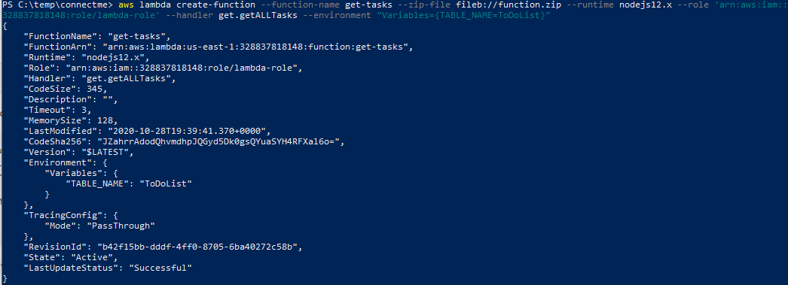

PS C:\temp\connectme> aws apigateway create-rest-api --name 'To Do List'

{

"id": "udy49vli5h",

"name": "To Do List",

"createdDate": 1603914998,

"apiKeySource": "HEADER",

"endpointConfiguration": {

"types": [

"EDGE"

]

}

}

PS C:\temp\connectme> aws apigateway get-resources --rest-api-id $ApiId

{

"items": [

{

"id": "7dgdmll6hl",

"path": "/"

}

]

}

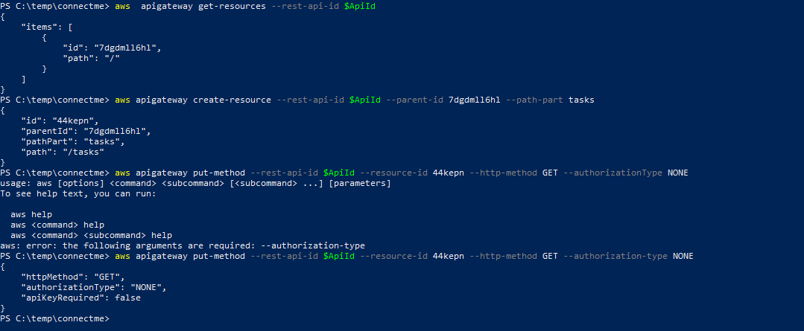

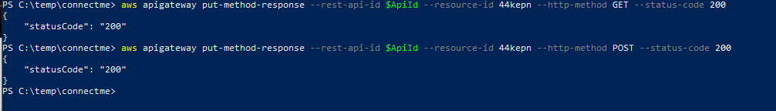

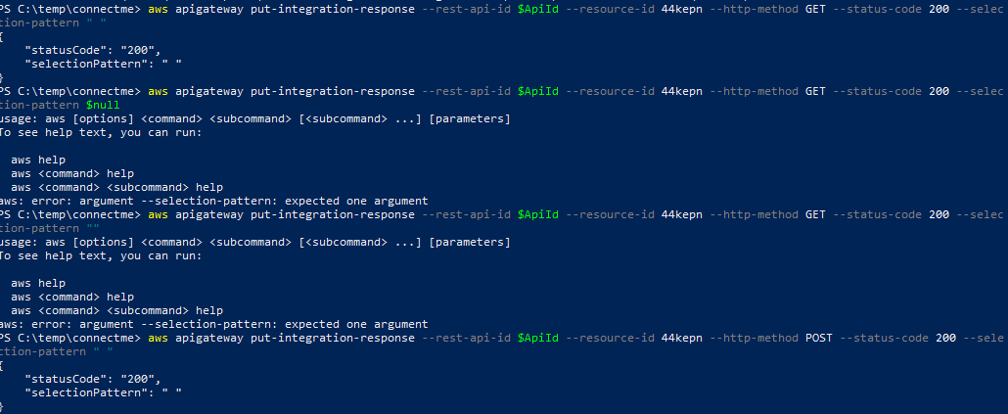

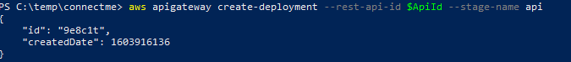

SENDING DATA

Persistent list

